OV SAN certificate
# Source: AI Source: Provided by: [Data Path: Persons Table -> ID Column: 1, Name_En Column: Motasem Essam] -> From: [ChatGPT] on [1/18/2026]
An OV SAN certificate is an Organization Validation (OV) SSL/TLS certificate that secures multiple domains or subdomains using Subject Alternative Names (SANs), while also verifying the legal identity of the organization.

🔐 What OV SAN Means
# Source: AI Source: Provided by: [Data Path: Persons Table -> ID Column: 1, Name_En Column: Motasem Essam] -> From: [ChatGPT] on [1/18/2026]
- OV (Organization Validation) → verifies the organization behind the domains
- SAN (Subject Alternative Name) → allows multiple domains to be listed in one certificate
- Intended for business or enterprise websites where trust is important
Example SAN List
example.com
www.example.com
api.example.org
secure.example.net
All these domains are covered, and the certificate includes the verified organization name.

🛠️ How It Works
# Source: AI Source: Provided by: [Data Path: Persons Table -> ID Column: 1, Name_En Column: Motasem Essam] -> From: [ChatGPT] on [1/18/2026]
- CA verifies domain ownership for each SAN entry
- CA verifies organization identity:
  - Legal registration
  - Physical address
  - Authority of the requester
- Certificate is issued listing all SAN domains
- Browsers recognize both the domains and organization identity
⏱️ Issuance time: Hours to a few days

📍 Where OV SAN Certificates Are Used
# Source: AI Source: Provided by: [Data Path: Persons Table -> ID Column: 1, Name_En Column: Motasem Essam] -> From: [ChatGPT] on [1/18/2026]
- Businesses managing multiple domains
- SaaS platforms or enterprise portals
- APIs and subdomains handling sensitive user data
- E-commerce platforms

✅ Advantages
# Source: AI Source: Provided by: [Data Path: Persons Table -> ID Column: 1, Name_En Column: Motasem Essam] -> From: [ChatGPT] on [1/18/2026]
- One certificate covers multiple domains
- Organization identity is verified → higher trust than DV
- Reduces management overhead (one cert for multiple domains)
- Strong encryption and browser recognition

⚠️ Limitations
# Source: AI Source: Provided by: [Data Path: Persons Table -> ID Column: 1, Name_En Column: Motasem Essam] -> From: [ChatGPT] on [1/18/2026]
- More expensive than DV SAN
- Longer issuance time
- Private key compromise affects all domains in the SAN
- Does not have EV-level branding

🔒 Best Practices
# Source: AI Source: Provided by: [Data Path: Persons Table -> ID Column: 1, Name_En Column: Motasem Essam] -> From: [ChatGPT] on [1/18/2026]
- Group domains with similar security requirements
- Protect the private key carefully
- Rotate and renew certificates regularly
- Use for business-critical applications

🧠 OV SAN vs DV SAN vs OV Wildcard
# Source: AI Source: Provided by: [Data Path: Persons Table -> ID Column: 1, Name_En Column: Motasem Essam] -> From: [ChatGPT] on [1/18/2026]
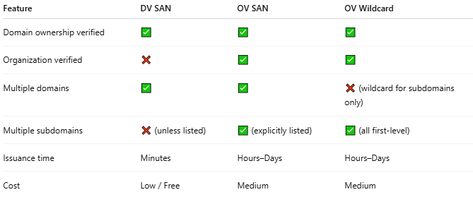
Feature | DV SAN | OV SAN | OV Wildcard
Domain ownership verified | ✅ | ✅ | ✅
Organization verified | ❌ | ✅ | ✅
Multiple domains | ✅ | ✅ | ❌ (wildcard for subdomains only)
Multiple subdomains | ❌ (unless listed) | ✅ (explicitly listed) | ✅ (all first-level)
Issuance time | Minutes | Hours–Days | Hours–Days
Cost | Low / Free | Medium | Medium

One-line summary
# Source: AI Source: Provided by: [Data Path: Persons Table -> ID Column: 1, Name_En Column: Motasem Essam] -> From: [ChatGPT] on [1/18/2026]
An OV SAN certificate secures multiple domains, verifies the organization behind them, and provides a trusted, enterprise-level solution for multi-domain business websites.

